Exercise 7
NAME: SHYAM SUNDAR K
ROLL NO: 241801268
CLASS: AIDS F

- Write a query to display the last name, department number, and department name for all
employees.
Sol
SELECT e.last_name,
e.department_id,
d.department_name
FROM EMPLOYEES1 e
JOIN DEPARTMENT d
ON e.department_id = d.department_id; 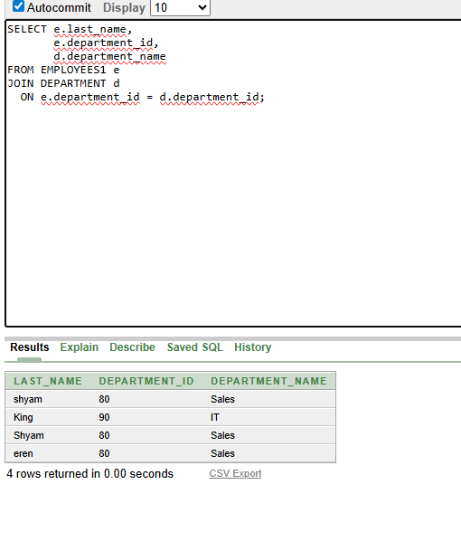

2. SELECT DISTINCT j.job_title,
d.department_name,
l.city
FROM EMPLOYEES1 e
JOIN jobs j
ON e.job_id = j.job_id
JOIN DEPARTMENT d
ON e.department_id = d.department_id
JOIN locations l
ON d.location_id = l.location_id
WHERE e.department_id = 80;

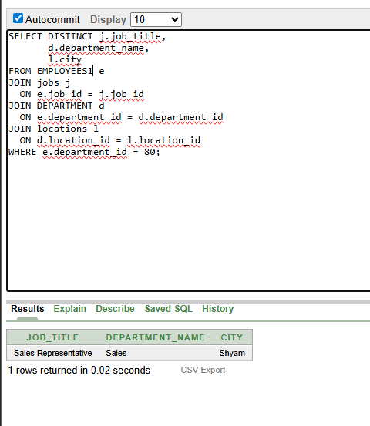
3 SELECT e.last_name,
d.department_name,
l.location_id,
l.city
FROM EMPLOYEES1 e
JOIN DEPARTMENT d
ON e.department_id = d.department_id
JOIN locations l
ON d.location_id = l.location_id
WHERE e.commission_pct IS NOT NULL;

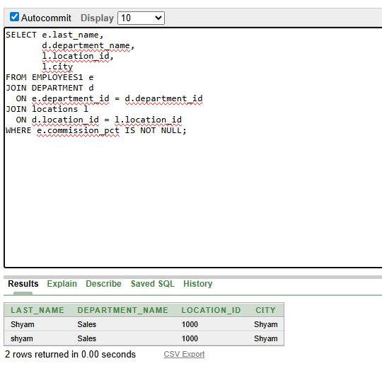

4 SELECT e.last_name,
d.department_name
FROM EMPLOYEES1 e
JOIN DEPARTMENT d
ON e.department_id = d.department_id
WHERE LOWER(e.last_name) LIKE '%a%';

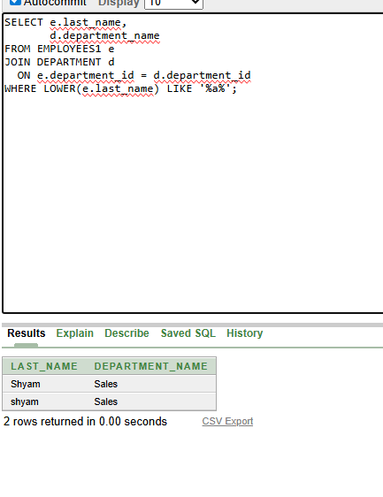
5 SELECT e.last_name,
e.job_id,
e.department_id,
d.department_name
FROM EMPLOYEES1 e
JOIN DEPARTMENT d
ON e.department_id = d.department_id
JOIN locations l
ON d.location_id = l.location_id
WHERE l.city = 'Toronto';
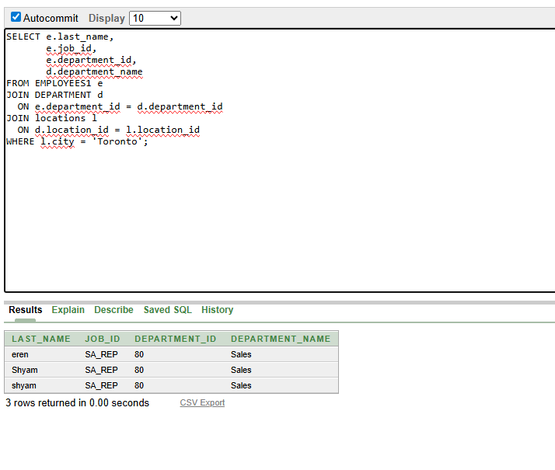
6 SELECT e.last_name AS Employee,
e.employee_id AS Emp#,
m.last_name AS Manager,
m.employee_id AS Mgr#
FROM EMPLOYEES1 e
LEFT JOIN EMPLOYEES1 m
ON e.manager_id = m.employee_id;
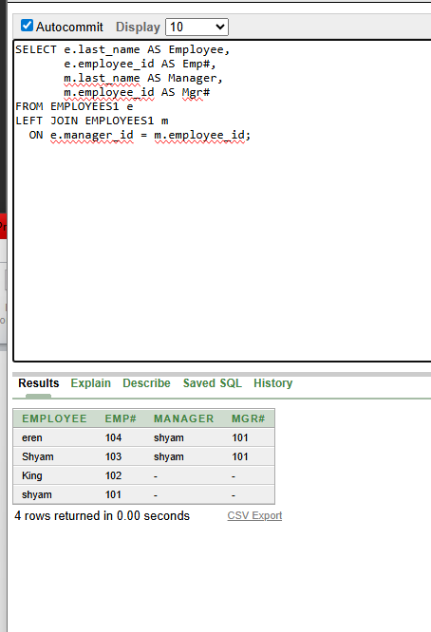
7 SELECT e.employee_id,
e.last_name AS Employee,
NVL(m.last_name, 'No Manager') AS Manager
FROM EMPLOYEES1 e
LEFT JOIN EMPLOYEES1 m
ON e.manager_id = m.employee_id
ORDER BY e.employee_id;
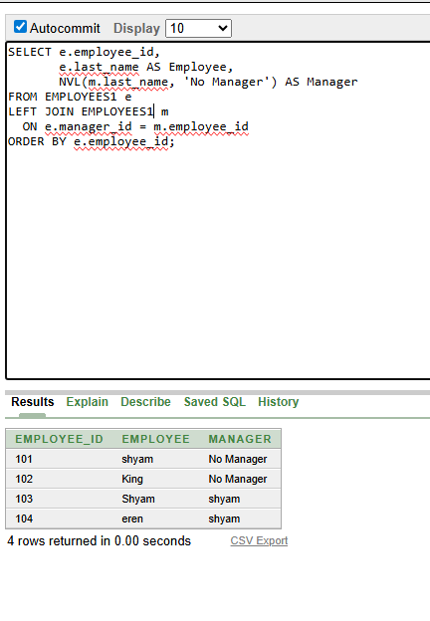
\8 SELECT e.last_name AS Employee,
e.department_id AS Dept#,
d.department_name AS Department
FROM EMPLOYEES1 e
JOIN DEPARTMENT d
ON e.department_id = d.department_id
WHERE e.department_id = (
SELECT department_id
FROM EMPLOYEES1
WHERE last_name = 'Davies'
);
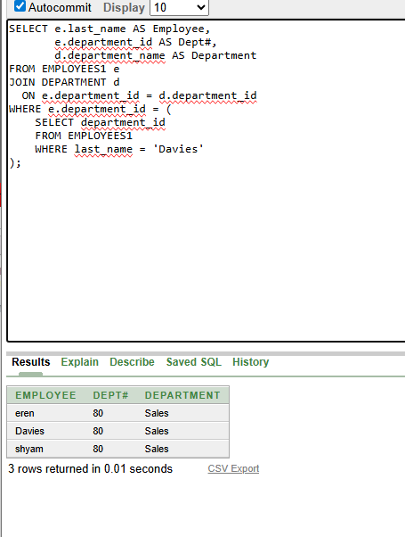
9 SELECT e.last_name,
j.job_title,
d.department_name,
e.salary,
g.grade_level
FROM employees e
JOIN jobs j
ON e.job_id = j.job_id
JOIN departments d
ON e.department_id = d.department_id
JOIN job_grades g
ON e.salary BETWEEN g.lowest_sal AND g.highest_sal;
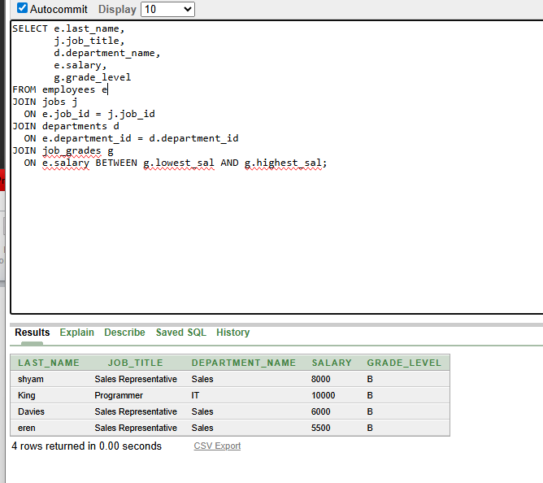
10 SELECT last_name,
hire_date
FROM EMPLOYEES1
WHERE hire_date > (
SELECT hire_date
FROM EMPLOYEES1
WHERE last_name = 'Davies'
);
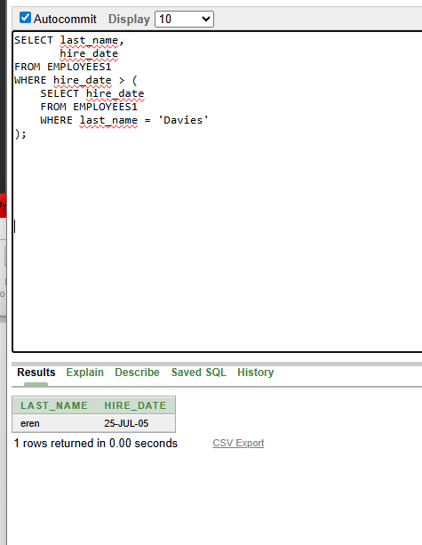

11 SELECT e.last_name AS Employee,
e.hire_date AS Emp_Hired,
m.last_name AS Manager,
m.hire_date AS Mgr_Hired
FROM EMPLOYEES1 e
JOIN EMPLOYEES1 m
ON e.manager_id = m.employee_id
WHERE e.hire_date < m.hire_date;

